**Problem Statement:**

Run parallel jobs in hive by following the steps in the below blog link

<https://acadgild.com/blog/hive-parallel-jobs/>

**Solution:**

Creating tables

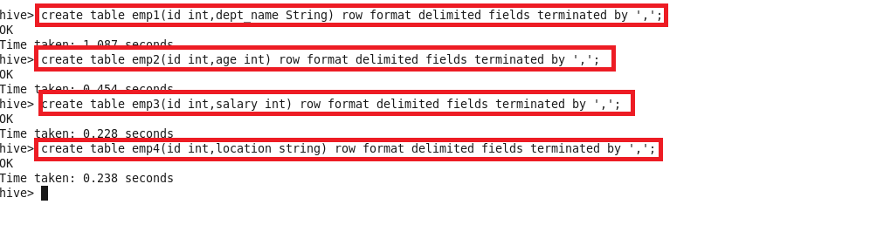

Loading data in these tables

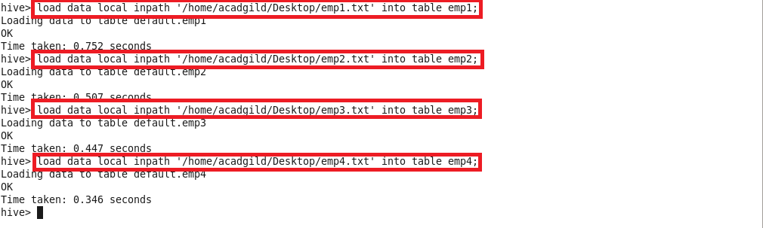

Contents of all 4 tables:

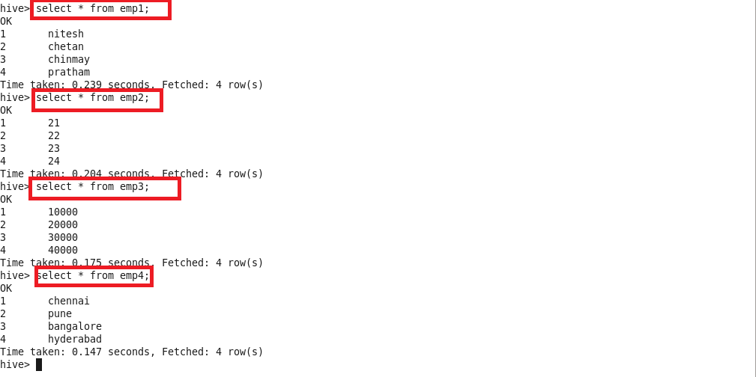

**Running parallel job:**

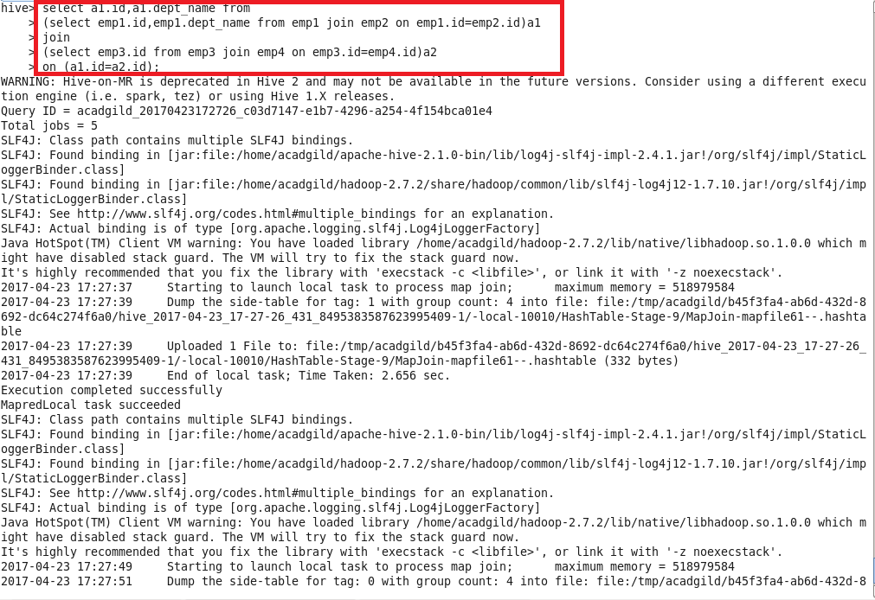

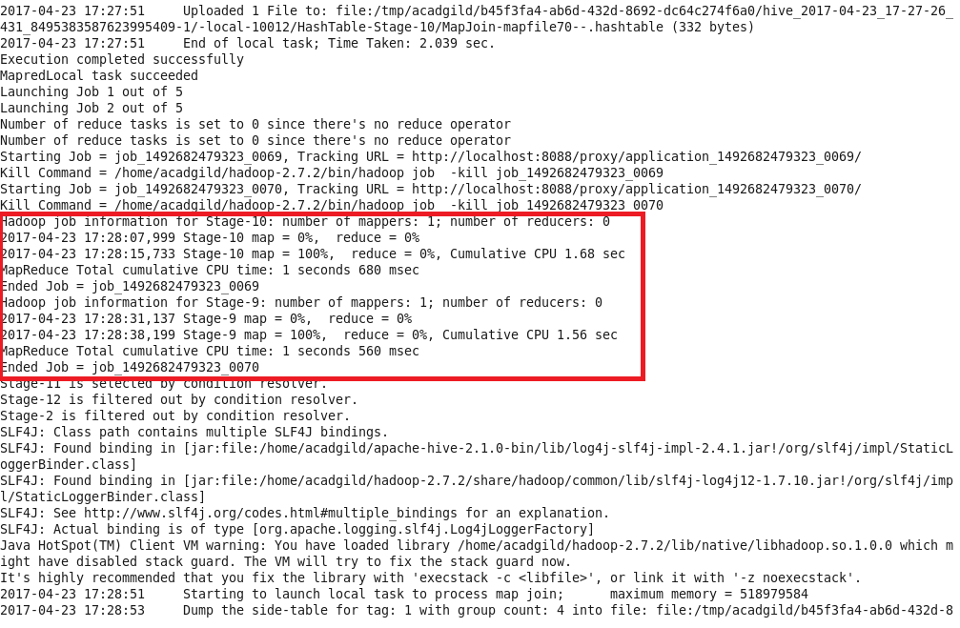

**Output:**

